**Week 7**

**10.ReactJS – HOL**

**FILE STRUCTURE  
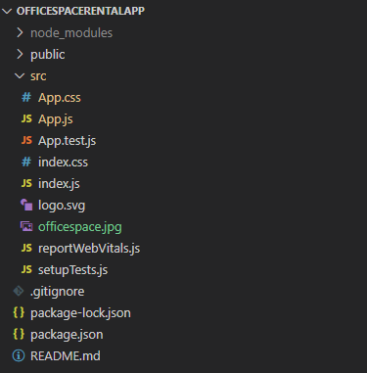  
  
CODE**

*C:\Users\User\Desktop\officespacerentalapp\src\App.js*

import logo from './logo.svg';

import './App.css';

import officespaceimage from './officespace.jpg';

const element = "Office Space";

const imageSrc = officespaceimage;

const ItemName = { Name: "DBS", Rent: 50000, Address: "Chennai" };

let colors = [];

if (ItemName.Rent <= 60000) {

  colors.push("textRed");

} else {

  colors.push("textGreen");

}

function App() {

  return (

    <div className="App">

      <h1>{element}, at Affordable Range</h1>

      <img src={imageSrc} width="25%" height="25%" alt="Office Space" />

      <h1>Name: {ItemName.Name}</h1>

      <h3 className= {colors.join(' ')} >Rent: Rs.{ItemName.Rent}</h3>

      <h3>Address: {ItemName.Address}</h3>

    </div>

  );

}

export default App;

*C:\Users\User\Desktop\officespacerentalapp\src\App.css*

.textRed{

  color: red;

}

.textGreen {

  color: green;

}

.App {

  margin-left: 280px;

  padding: 20px;

  font-family: Arial, Helvetica, sans-serif;

}

**OUTPUT**

